PARISH NEWS
The Deverills & Crockerton
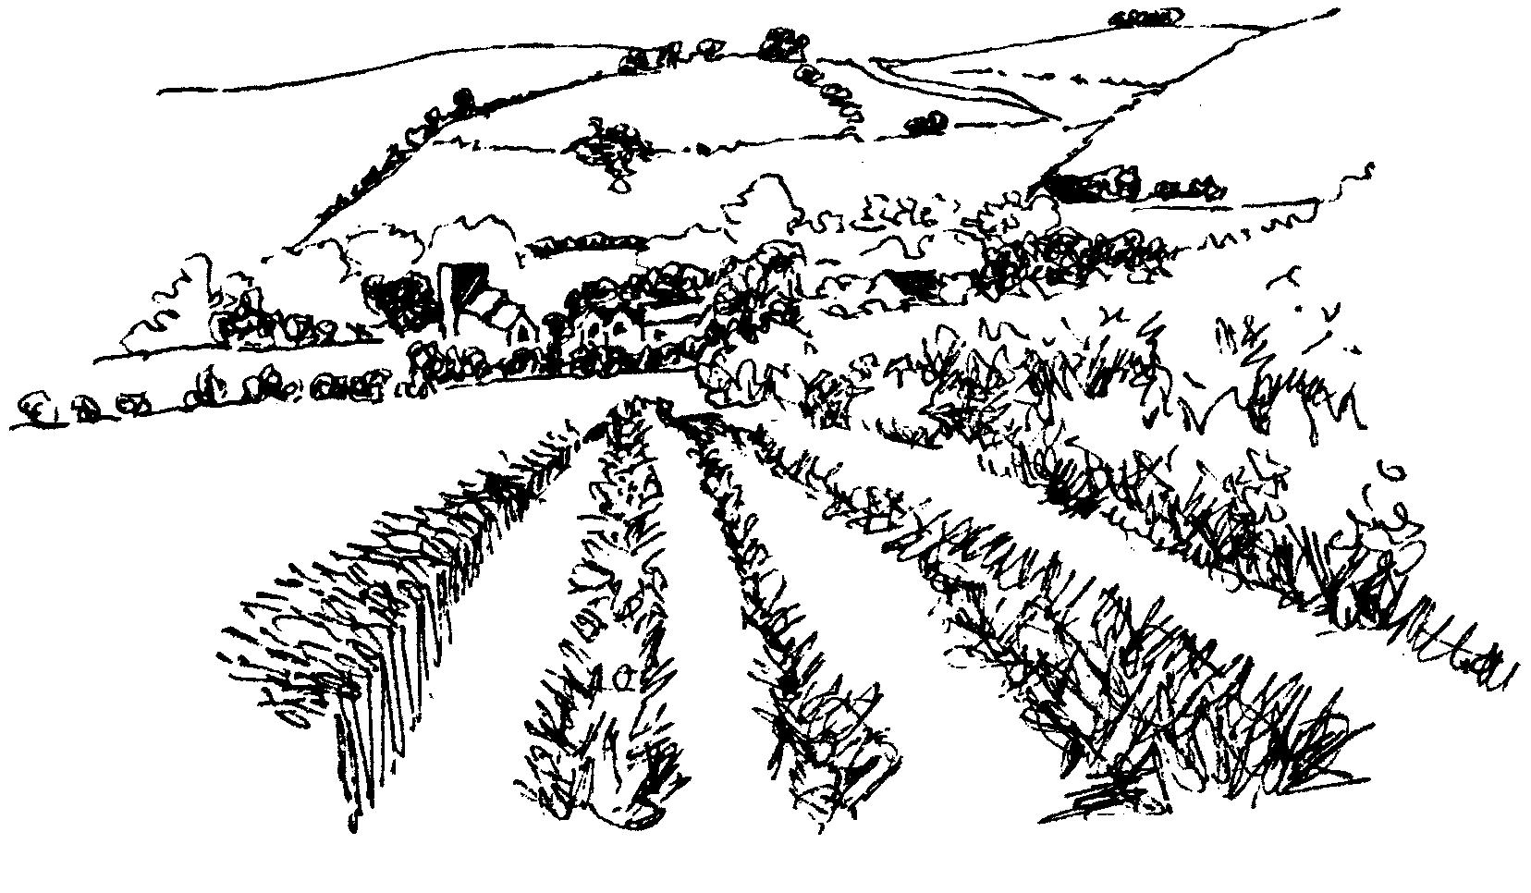

Brixton Deverill from the East
by Pat Armstrong

October 2008

Look inside for local information

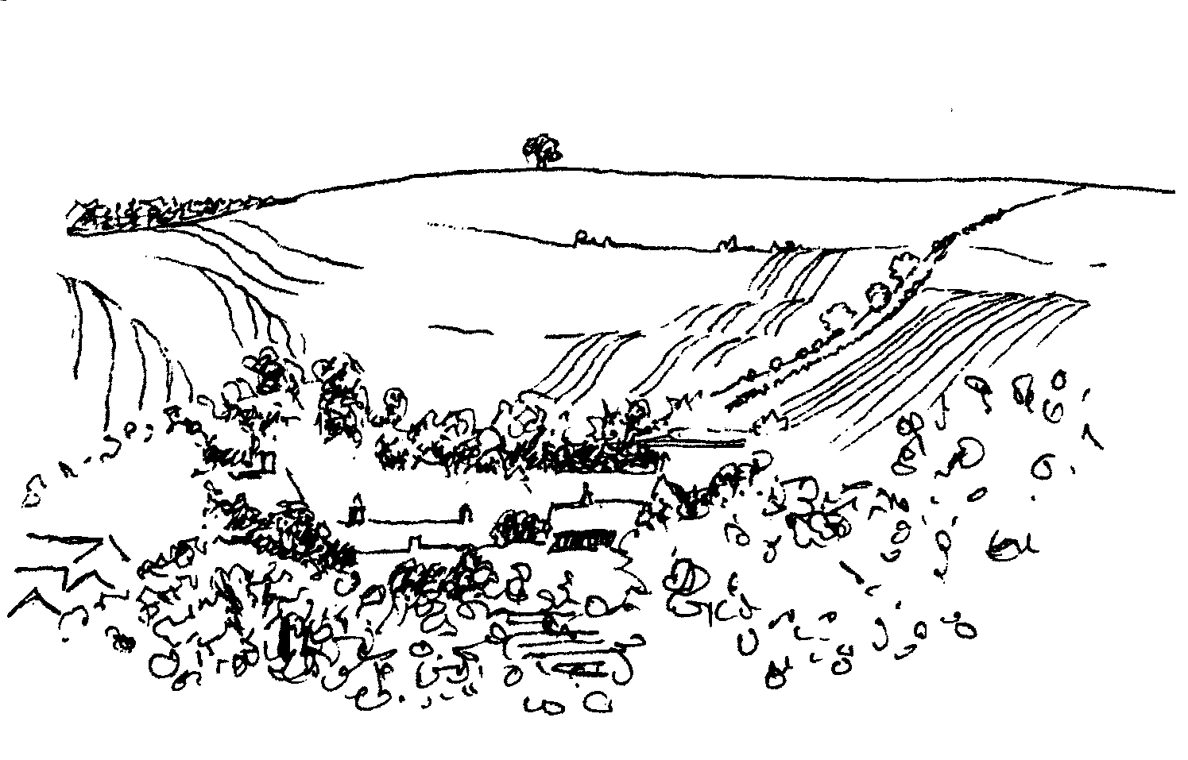
-2-

Fight for Sight Fair
10.00 am - 3.30 pm Thursday 2nd October
We are coming back to the Deverills!
Our new venue is the Rye Hill Barn
(on the road from Longbridge Deverill to Maiden Bradley)
Lots of new stallholders
All your Christmas shopping in one go
Meet friends for a delicious lunch or snack made by Sandy Parrish
Meet friends for a delicious lunch or snack made by Sandy Parrish



Longbridge Deverill Village Hall
HARVEST SUPPER
Saturday 4th October 7.30 pm for 8.00 pm
All are welcome to this popular annual event
Bring your own wine. Tickets £10 from
Mrs Titt (214825) or Mrs Wood (840535)

Charity Event

Longbridge Deverill Village Hall
Saturday 18th October from 10.30 am to 3.30 pm

Christmas & Greetings Cards
On sale for Cancer Research UK and Children’s Hospices UK

Refreshments : Coffee & Ploughman’s Lunch
In aid of Help for Heroes and the Deverills Churches

Upper Deverills Village Hall
HARVEST SUPPER
Saturday 18th October
7.00 pm for 7:30 pm
Book early for this popular event
Tickets £10 from Richard Cousens (844970)

-3-

The Rector writes:
How time flies! Or so it seems to me this year. Already the hints of autumn are abundant and the season of mists and mellow fruitfulness has definitely arrived.
I always find September a pivotal month. It spans the days between summer and autumn, often exhibiting signs of the two seasons it seems to link. As we move into October, the school term is well established. Many young people who left school earlier in the year will be venturing into the world of further education, as others continue their studies or travel or grow in confidence in the world of work.
As we look forward, already Christmas is on the horizon. Christmas cards and decorations are in the shops. A variety of gift catalogues drop through the letter box in the hope that we will be encouraged to get on with our Christmas shopping.
However, there is much to occupy us before the festive season. At present, we are in the midst of the Harvest Festival season. Other celebrations will quickly follow. Bible Sunday, All Saints-tide, All Souls’ when we commemorate the departed, Remembrance Sunday lead into Advent and Christmas. During the coming months, there will be opportunities to come together to mark each of these festivals. In addition, there will be opportunities to learn together in an Advent Bible Study. Confirmation groups will commence during the autumn, and anyone interested in exploring the faith more deeply, should contact me (Tel: 841321) or Rev Di Britten (Tel: 01373 832515). In November there will be a Quiet Morning and a Quiet Afternoon, ideal opportunities to put time aside for reflection and prayer (details later).
It seems vital during these unsettled and unsettling times, as the world is facing financial and environmental issues which seem to grow by the day, that we hold on to that which shapes our lives and gives life meaning. All that lies at the heart of faith, all that enriches and sustains, is worth reflecting on.
I hope that you will feel able to join some of the events that will be happening in our Benefice during the autumn. With every blessing,
Norma Payne
Ride & Stride
Well done to Richard Munro and Louise Stratton for their valiant bicycle riding on Saturday 13th September, which celebrated the 25th Anniversary of the Sponsored Ride and Stride for the Wiltshire Historic Churches Trust’s annual fund raising event. They raised £750.00 between them by their energetic cycling and through the generous sponsorship of many supporters. Thank you to everyone involved with this event including those who ‘manned’ the churches.
Judy Munro 844385
Gerald Sweet - Organist
Gerald suffered a stroke recently and would like to say “a big THANK YOU to you all for your thoughts and prayers during my recent illness which, no doubt, have enabled me to come through it with good prospects of recovery in due course. I am also very grateful for the many kind messages I have received directly. May God bless you all.”

-4-

Meet friends for a delicious lunch or snack made by Sandy Parrish
Deverill Valley & Crockerton Women's Institute
Longbridge Deverill Hall
Monday 13th October 7.30 pm - Group Meeting
‘Butterflies of Britain’ with Derek Remington
Social time: Scrapbook - Refreshments served
Monday 27th October - WFWI Annual Meeting
Come and join us, you will be very welcome
For more information contact Ann Dufosee 840360

Meet friends for a delicious lunch or snack made by Sandy Parrish
Salisbury Theatre Club Trips
Monday 20th October
A Taste of Honey by Shelagh Delaney
Monday 17th November
A Month in the Country by Philip Wilson
The cost is £17.00: theatre seat £12.00 and coach trip £5.00
Booking and payment in advance to Mary Stewart Cox Tel 840877
Longmead, Brixton Deverill, Warminster BA12 7EJ
Coach leaves Kingston Church 6.10 pm collects through the Deverills


Meet friends for a delicious lunch or snack made by Sandy Parrish
Tango Classes in Crockerton
at The Old Pottery, Bull Mill
3 part course on
Saturday 11th October, Saturday 8th November,
and Saturday 6th December
Absolute beginners welcome!
For more details please call Olivia and Daniel on 212716

2009 Wylye Valley Calendar
Following the success of last year’s calendar, sales raised £6,525 for Hope and Homes for Children, the 2009 edition is now on sale! Slightly smaller this year, with 12 inch square photographs, but again covering the whole area from Wilton to The Deverills. The March page features a lovely picture of the church at Brixton Deverill. All proceeds will again be donated to Hope and Homes for Children, an international children’s charity based in the Wylye Valley and working across Africa, Central and Eastern Europe to transform the lives of children who are orphaned, abandoned or vulnerable (Registered Charity No 1089490). You can purchase the calendar @ £8.95, including an envelope, from Hallmark Cards,
12 -14 Market Place Warminster, or online at www.wishfordarts.co.uk and view the images, or by contacting me, Chris Lock, by phone 01722 790817.

-5-

Upper Deverills Village Hall
Eddie Mirzoeff Film Night - Friday 3rd October doors open 7.00 pm
The film to be shown on this occasion is ‘Elizabeth R’. It was first broadcast on 6th February 1992, in celebration of the 40th Anniversary of the Queen's accession to the throne. The filming took place over 18 months, during which the team was allowed unique and unprecedented access behind the scenes at Buckingham Palace, Windsor, Sandringham, Holyrood and Balmoral - as well as on the Queen's visits to the United States and Zimbabwe - and a sudden secret journey across the water. There are grand State occasions and intimate family moments, the tension of the Gulf War and the relaxation of Derby Day; portraits are painted, knighthoods bestowed, the Prime Minister comes for a chat, world leaders assemble for summit meetings, and always there is the unrelenting daily round of audiences, boxes, correspondence. The revelation of the film lies, perhaps, in the Queen's unexpectedly lively and sharp sense of humour. This film was shown around the world and achieved the highest audience ever for a documentary, and won two BAFTA awards. It has not been screened since 1992. Come and enjoy a great evening; please bring your own wine.
Future Events: Remembrance Lunch Sunday 9th November,
Quiz Night Friday 14th November, Carol Service Sunday 21st December
Upper Deverills Rights of Way Fund
A residual sum of £234 remains in the Upper Deverills Rights of Way Fund which was constituted to challenge the reclassification of a local Road Used as a Public Path (RUPP). Since there is no remaining use for this fund, it is proposed to transfer the remaining sum to the Upper Deverill’s Village Hall to the benefit of the local community. If any donor to the original fund has any reservation on this matter please contact Richard Cousens 844970 by 31st October.
‘Longbridge Deverill Parish Memories’
This new local interest book compiled and published by the Longbridge Deverill Social History Group will be on sale for the first time on Saturday 1st November from 12 noon until 6.00 pm in Longbridge Village Hall. Under the terms of the Awards for All funding received by the publishers, a free copy of the book will be given to each household in the civil parish of Longbridge Deverill which includes Hill Deverill and Crockerton. Any of these copies not collected that afternoon will be delivered by volunteers in due course.
An Exhibition of Bygones and Photographs will also be open from 12 noon to 6.00 pm. Over a century of Parish life will be on display in the Hall. The WI will be serving refreshments. There will be no charge for this community ‘get together’ as it is funded by Awards for All.
Community Contact Point ‘Drop In’
Ian Owen, our Police Community Support Officer, will be in the Upper Deverills Village Hall on Saturday 4th October from 2.00 - 4.00 pm to give security advice and listen to the concerns of residents. Please call in and see him.

-6-
Women’s Refuge
I have received a warm letter of thanks for the kind generosity of the people of the Deverills & Crockerton who kindly donated items for the residents of the Refuge. They always have need for toiletries, babies and children’s clothing which can be left with me for delivery to them.
Barbara Beilby 844995
Warminster & Villages Community Day
Warminster Assembly Rooms Friday 17th October 10.00 am - 6.00 pm
This day will provide an opportunity for everyone to find out more about the new Area Board, to celebrate the work of local groups and organisations and to feed in the views of local people on the issues identified in the Warminster Community Area Plan, the Town Plan Scoping Study, and equivalent Parish/Village plans. All local people, groups and organisations in the Warminster Community Area are invited to attend, even if only to drop in for a few minutes. Further information can be obtained from Mary Cullen by telephone on 07709 245496 or e-mail: marycullen@wiltshire.gov.uk
Warminster Decorative & Fine Arts Society
Do you know about us? We are a member society of NADFAS (The National Association of Decorative & Fine Arts Societies) and we meet on the third Monday of each month, except August and December, to enjoy an Arts related lecture at the Standerwick Centre. The lectures are given by professional lecturers, experts in their subjects. Those subjects range from the Queen of Sheba to Christian Dior via Grinling Gibbons and Angelica porcelain and silver through the ages. Would you like to join us? For more details contact: Martyn Willey on 216295 or Caroline Dunseath on 01373 824224 (dunroy100@aol.com)
Mere Literary Festival 13th - 19th October
Mere Literary Festival opens as usual on the second Monday of October and the organisers have again lined up an eclectic programme at affordable prices. Authors appearing include Ruth Waterman, Justin Pollard, Adrian Tinniswood, Malcolm Welshman, Richard Hallows, Michael Dobbs, Liz Jones, John Harris, Rex Sawyer and Marion Molteno. There is a reminiscence afternoon, a Diary Day, a writing workshop, film, live theatre and words and music from organist David Power recounting A Powerful Journey. You can enter a team in the popular Literary Quiz with a chance to win The Lawrence Shield or Jeanette Francis Cup. Results of the festival’s short story competition are announced at the Award Ceremony on its final day. You don’t need to be an entrant to come along to hear the adjudications or browse the bookstalls. For full details and booking pick up a big green programme or log on to www.merelitfest.co.uk. Tickets are available by post with a booking form from the website or at Mere Information Centre/Library 01747 861211 or the Festival Organiser 01747 860475 or the Book Exchange Monday - Friday at The United Reform Church. Proceeds from the festival support the Mere & District LinkScheme (Reg.Charity No: 1062328)

-7-

Mere Literary Festival Events 13th - 19th October
Monday 13th When Swan Lake Comes to Sarajevo with Ruth Waterman. The distinguished violinist recounts her experiences working with the Mostar Sinfonietta after the Bosnian war, the subject of her recent book. Grove Buildings 7.30 pm £6 in advance, £7otd

Tuesday 14th Memory and Story A relaxed reminiscence afternoon led by local librarians. Spark off memories. Share stories. Lecture Hall 2.30pm Free

Two Local Heroes by two noted Biographers - Justin Pollard and Adrian Tinniswood together discuss their respective biographies of Alfred the Great and Sir Christopher Wren. Biography at its best! Grove Buildings 7.30 pm £6

Wednesday 15th It’s a Vet’s Life Malcolm Welshman gives a light and humorous talk about his work with animals, from the exotic to the household pet and how these experiences influenced his new book Pets in Prospect. Grove Buildings 2.30 pm £3
Literary Quiz - David Jeffery - teams (max. 4) Grove Buildings 7.30 pm £2 pp
Film Night - The Edge of Love the story of Dylan Thomas. Lecture Hall 7.30 pm £5

Thursday 16th Diary Day Write up your day, make historic record for posterity.
Diary of a Reluctant Green - Richard Hallows talks about his ‘personal experience’ book based on his sometimes hilarious attempts to be green. Lecture Hall 2.30 pm £3
Pepys and the Playhouse Actor Colin Pinney presents his one-man show about the most famous diarist in history. ‘Hugely enjoyable’ – Cheltenham Festival Lecture Hall 7.30 pm £5

Friday 17th Writing Workshop Story skills with creative writing tutor Cath Drake. Numbers Limited. To book contact organiser Grove Buildings 2.15 - 5.00 pm £12 inc. tea
An Evening with Michael Dobbs Famous for his novel House of Cards, which became a hugely successful TV drama, Michael Dobbs is the author of 15 thrillers and his new book The Edge of Madness is published in October. Grove Buildings 7.30 pm £7 in advance, £8otd

Saturday18th Coffee & Talk with Liz Jones Fashion guru, columnist, author, famous for the personal revelations in her book How a Single Girl Got Married and her regular column Liz Jones’ Diary. Not to be missed! Grove Buildings 10.15 am Retiring donations
Children’s Event Storyteller John Harris at Mere Library 2.00 pm Free
A Powerful Journey - David Power describes his journey to play the organ in every English cathedral and performs some of the music United Reformed Church 7.30 pm £6 in advance, £8 otd

Sunday 19th Award Ceremony Adjudications by Marion Molteno, Rex Sawyer, Win Richardson. Lecture Hall 3.00 pm Book stalls from 2.30 pm Free

-8-
SERVICES PARISH OF DEVERILLS & HORNINGSHAM
Sunday Trinity 20
5th October Kingston - 8.00 am Holy Communion 1662
Rev Norma Payne
Longbridge - 10.30 am Harvest Festival*
Rev Norma Payne
Horningsham - 6.30 pm Harvest Festival*
Rev Norma Payne
Sunday Trinity 21
12th October Kingston - 10.30 am Holy Communion
Rev Di Britten
Horningsham - 11.15 am Holy Communion 1662
Rev Norma Payne
Sunday Trinity 22
19th October Longbridge - 8.00 am Holy Communion 1662
Rev John Goodden
Brixton - 10.30 am Holy Communion
Rev Norma Payne
Sunday** Trinity 23
26th October Longbridge - 10.30 am Holy Communion
Rev Norma Payne
Horningsham - 11.15 am Morning Prayer
Col Robin Chappell
Brixton - 6.00 pm Evening Prayer
Rev Norma Payne
Sunday 4th before Advent
2nd November Brixton - 8.00 am Holy Communion 1662
Longbridge - 10.30 am All Souls***

Tuesday, Wednesday, Thursday, Friday Longbridge 8.30 am Morning Prayer
Wednesday Longbridge 10.15 am Holy Communion

*Harvest Festival collections of items will be in aid of the Trussell Trust.
** British Summer Time Ends (clocks go back one hour)
***All Souls Service We hope those who wish to remember friends or family who have died, particularly in the past year, will join us for this service and for refreshments afterwards.
THE DEVERILLS & HORNINGSHAM REGISTER
Marriage
Jon Hodges & Hannah Pickford Saturday 6th September at Horningsham
Funeral
Doreen Allard Friday 19th September at Horningsham

THE DEVERILLS & HORNINGSHAM REGISTER
Marriage
Jon Hodges & Hannah Pickford Saturday 6th September at Horningsham
Funeral
Doreen Allard Friday 19th September at Horningsham

-9-

SERVICES PARISH OF CORSLEY & CHAPMANSLADE
Sunday Trinity 20
5th October Corsley - 9.00 am Holy Communion
Rev Di Britten
Sunday Trinity 21
12th October Chapmanslade - 9.00 am Family Holy Communion
Rev Norma Payne
Temple - 11.00 am Morning Prayer
Col Robin Chappell
Sunday Trinity 22
19th October Chapmanslade - 9.00 am Holy Communion
Rev Norma Payne
Corsley - 6.00 pm Evening Worship
Rev Norma Payne
Sunday Trinity 23
26th October Temple - 9.00 am Holy Communion 1662
Rev Di Britten
Corsley - 10.30 am Parish Service
Rev Di Britten
Sunday 4th before Advent
2nd November Corsley - 9.00 am Holy Communion

Sudan - giving at no cost
Last year sales of Christmas cards in aid of Sudan, made from recycled cards, raised £5,000 in the Diocese. Sales of used postcards over the last three years has raised £36,000. Please, if you have any old cards put them in one of the three Deverill Churches labelled SUDAN. The remade Christmas cards, by Jane Yates, will be on sale in the Churches and at the Mothers and Toddlers Group.
Jazz Evening at Brixton Deverill
I would like to thank everyone who helped to make the evening with the 4.4 Jazz Band at St. Michael’s Church such a success. I admit that as the bookings grew so did my anxiety, but I needn’t have worried. A special mention and many thanks go to Johnny and Pony Burridge for welcoming us so generously to the Manor for the pre-concert supper. I had mentioned that there might be about thirty people, I never saw them blanch as seventy of us poured in! As for the supper, Janet Budgen produced a magnificent meal, as good as any high class restaurant. I hope the many compliments floating around reached her and her ‘team’. To all who produced so many delicious salads and desserts or managed the wine a big ‘Thank you’. It was Pat Armstrong who pointed out the English custom of asking willing friends to produce various foods, and then charge them to come and eat it! It works wonderfully, we raised £881.00 net for the Deverill Valley Churches Fabric Fund. Lastly thank you all so much for coming to make it such a happy occasion.
Mary Stewart Cox

-10-


Odd Job Lady
Haven’t got round to it! Let me do it!
Gardening - Carpentry - Decorating - Cleaning
Woman with Van - Helping Hand - Domestic Repairs
Trustworthy and Cheerful - References available
Contact Jules on 01747 820796 or 07522 377663

Ivy House St Denys Retreat Centre
Monday 13th October
House Quiet Day with Jeanne Blowers
For more information please phone 214824

Church Cleaners for October
Kingston - Mrs Stratton & Mrs Mounde
Brixton - Mrs Allard & Mrs Sutton
Longbridge - Monday 6th October 9.30 - 10.30 am - all helpers
Church Flower Arrangers for October
Kingston Brixton Longbridge
5th Oct Mrs Munro Mrs Sutton Mrs Honley
12th Oct Mrs Munro Mrs Hammick Mrs Honley
19th Oct Mrs Gatt Mrs Hammick Mrs Steptoe
26th Oct Mrs Gatt Mrs Marsh Mrs Steptoe

CONTACT THE EDITOR AND WEBSITE
Parish News Editor - Judy Munro 844385
Contributions for the Parish News through my letterbox or
by post to Whitepits Lodge, Kingston Deverill, Warminster,
BA12 7HD or by Email: judymunro@tiscali.co.uk Thank you
Please remember the deadline is the 15th of every month

Website: www.deverills.org.uk Email address:info@deverills.org.uk
Website manager : Kate Wilkinson 844998
Contents: Parish News with church services, Parish Register, Events, Local News plus pictures and other information
Contact the Clergy
Please contact Rev Norma Payne (841321) or another member of the Clergy (see back page) if anyone is housebound and would like communion or a visit at home; or if you know of anyone who is ill and needs our prayers; or you wish to discuss any church matter.
Contact the office Administrator by email: office@cleyhill-team.org.uk or by telephone 210149.
-11-

Longbridge Deverill and Crockerton Parish Council
Once a month the Parish Stewards visit our villages. They are employed by Wiltshire County Council to undertake the smaller jobs that are often overlooked, but are extremely necessary to make our lives safer. This includes clearing annual growth around road signs and visibility areas and cutting back growth from pavements. During October and November they are especially keen to visit drainage grips and gully covers to reduce the number of floods. The Stewards rely on local Councillors to give them information about any problem areas, so if you have seen any problems near your home or whilst walking let us know. Our visits are usually at the end of each month, so give me a call (840119) by the 15th and I can send in our job sheet!
The next Parish Council meeting will be held at Longbridge Deverill Village Hall on Monday 3rd November at 7.30 pm. Members of the public are very welcome.
Helen Few - Clerk
Pause - for an extra few seconds
Monday 8th September was the start of term for the Reception year at Crockerton school, an exciting dawn for many eager minds and a significant step for a lot of parents, including ourselves as our daughter joined her elder brother. Johanna has been talking about going to school and becoming a 'big girl' since the holidays began, she was really looking forward to it!
My wife Wendy was doing her usual Monday stint on the 'stop-and-drop' team. There was an incident that nearly resulted in Johanna being run over. Both Johanna and Wendy were and still are upset by it. When I got home that evening and asked Johanna about her first ever day at school, she burst into tears. It's unfortunate that I can't console her with this being 'a one-off' because in her mind, school - or going to school - is a dangerous experience. She is 4 years old and terrified of going to school, it's not how I or anyone would want a child to embark on their school career. I know both residents and parents alike will be saddened to read this, but that's not why I'm writing it, although thank you to everyone who has offered good wishes and support!
There are two reasons for this small article. The first is to thank those of you, again residents and parents alike, who are courteous, patient, and understanding. It's always important to remember, and you do, that your actions set a role model for our younger generations to follow. No matter what we try to teach our children, their own observations and experiences have a great impact on them, which is why role models are so important. The second reason is linked to the first. The actions of the car driver have had a huge impact on my family. I know that we have issues with traffic management around the school, as adults we are trying to find reasonable ways forward to try to address this. But let's not forget that the unwitting victims of incidents like this are children, they can't fight back, and as adults we generally try to teach them that talk is better than fight. So please, let me re-enforce the message - just give an extra few seconds - it won't add much to your journey, but it will stop another child being in this situation. If you are the driver of the car reading this, then please talk to me or the representatives (resident or parent) on the Crockerton forum so that we can try to help alleviate the situation that caused this incident. Thank you.
Graham Dopheide

-12-
Where have you been? The Bell and Crown, Zeals
We have passed the Bell and Crown many times on our way into Wincanton but have never been tempted to cross the threshold. However, after a hot tip from a friend in Monkton Deverill that the new landlord was John Harrington, the man who had run such places as The Black Dog at Chilmark, The Malet Arms at Newton Tony and The Angel at Hindon when each one of them had been in its heyday, we decided to give it a try.
What a difference a keen and enterprising landlord can make to a pub! The whole interior has been refurbished in the current trend of mismatched old tables and chairs that look as though they have been accumulated by a family over several generations, a sort of ‘heritage chic’, but nothing too pretentious. The pub has a very attractive bar area where you can dine (and take your dog) plus a slightly more formal restaurant with uniform chairs and tables. We went for Sunday lunch in late July with a couple of youngsters from our family who are fairly expert in the country pub field. They enjoyed it greatly. Those of you who know any of John Harrington’s previous pubs will have some idea of what to expect – good food and wine at reasonable prices. We also met some familiar bar staff who had gravitated to the Bell and Crown from other pubs in the area – must be a good sign! I think this will prove to be a winner locally as it is just a short drive for most of us. Food is available every day, except Sunday evening. I would recommend booking for Sunday lunch, the telephone number is: 01747 840404.
Finally the usual plea for contributions but with a slight twist this time as it occurs to me that it might be useful to have a top ten of places to eat locally, perhaps along the lines of what is going up and what is coming down in attractiveness. Please send your suggestions to me by email at farthings.kd@btinternet.com or through my letter box at Farthings, Kingston Deverill. Looking further ahead, I am thinking of giving some examples of places to go for ‘Posh Nosh’ for special occasions so any recommendations for where to go for ‘push the boat out’ meals would be very welcome.
Trish Shuler 844291
The Monkey Puzzle Tree in Longbridge Churchyard
The Monkey puzzle tree In Longbridge Churchyard is looking old and shabby and has been loosing branches, cones and bird nests this year, so sadly it will probably have to be felled in case problems arise. There is a young, and reasonably fast growing, one in the garden next to the Parish Hall car park. Checking my book ‘The Secret Life of Trees - How they live and Why they matter’ by Colin Studge it is listed in the Conifers as Kauris and the Long lost Wollemia Family Araucariaceae. This family of trees was in existence in dinosaur times in the Pacific islands, New Zealand and South America. One tree in Tane mahuta was thought to be 1,500 years old. The one in the Churchyard was possibly planted by the Marquess of Bath in the late 19th Century but I have not searched records to confirm this.
Elisabeth Atkinson

-13-

Nature Notes
Suddenly it seems like autumn. I had been hoping for a little summer before it came but it’s too late now! This morning when I awoke it was very misty and the cobwebs in the beech hedge were covered in dew and were sparkling just like jewels. I knew then that autumn had definitely arrived and summer would not return. I should have realised already for there have been signs: the swallows gathering on the wire, the tawny owls calling in the evening, the ‘tinkling’ song of the ‘autumn’ robin and the passage of summer migrants - wheatear, willow warbler and chiffchaff. Perhaps we will have a lovely autumn that will last until the end of October. I do hope so, at least then there will be time for the harvest to be gathered in, the soil to be cultivated and next year’s crop sown. This next week sounds as if it might be dry so let’s hope the fields that are still with a standing crop can be combined and the straw baled and safely stored away.
I have noticed a change in the birds coming to feed in the garden. The coal tit is back having been up in the woods for the summer and there are less blue and great tits. Parties of long-tailed tits have begun to come through the garden calling to one another as they go. The goldfinches seem to have gone out into the hedgerows as do the tree sparrows. There are not so many chaffinches either. In their place there are greenfinches and house sparrows. The other day I saw an adult house sparrow feeding a youngster - a late brood. We have had two late broods of house martins that have flown very recently. I hope that they manage to build up enough fat reserves for their journey south. I think most of the house martins and swallows have already started to migrate south and those that are about are either late broods or birds that have come from up north. Today there was a nuthatch calling in the garden and I located it on the acacia tree. I have heard bullfinches calling from behind the house but so far haven’t seen any in the garden, they are so shy I don’t normally hear them close to the house until well into the autumn.
We have had a hare visit our patio on several occasions recently; it appears to be a youngster not fully grown. It has been eating the dandelions growing between the slabs. You don’t usually get to see a hare so close for any length of time, it was fantastic to be able to sit and watch it while it ate without any knowledge of us being there. I wish I could get closer to the deer that we have around on the farm. A doe and a buck have set up quite a friendship and are often together. Sadly this evening when out for a walk we disturbed them and the doe went one way and the buck the other. I hope they got back together for the night!
Jane Trollope (written 14th September)
Two Goats: Free to a good home.
We have been looking after two goats, but sadly we don’t have enough room in our garden to keep them permanently so we are searching for a new home for them. The goats are about 3 years old, born at Farmer Giles. They are very friendly, completely tame with people and dogs, and happily walk on a lead. They are inseparable brothers, and must find a home together. Castrated males make the best pet goats, and they don’t smell! Fully wormed, vaccinated, DEFRA registered. The British Goat Society website is a good source of information for potential goat owners. For all enquiries, please call Daniel Petkoff on 212716.

-14-

LOCAL COUNCILS, SOCIETIES, GROUPS etc.
Longbridge and Crockerton Parish Council
Karen Manfield 215526 (Chair) Peter Whithey 840347 (Vice Chair)
Helen Few 840119 (Clerk) Tom Minter 216909
Bill Hurd 840023 Elaine Pidgeon 212878
Julian Algar 840816 Graham Read 840296
Brian Marshall 214789
Upper Deverills Parish Council
Lady Felicity Wheeler 844683 (Chair) Ranald Blue 841374
Jacqueline Smith 840238 (Clerk) Patricia Shuler 844291
Sarah Fagan 844123 Robin Greenwood 840743
District Councillor
Shear Water Ward - Michael Mounde 844363
Longbridge Deverill Village Hall Committee
Jo Nelson 840784 (Chair)
Barbara Smith 840251 (Secretary) Sylvia Titt 214825 (Caretaker)
Upper Deverills Village Hall
Richard Cousens 844970 (Chair)
Mandy Martyn 844320 (Secretary) John Lea 844325 (Hall bookings)
Crockerton Millennium Committee
Marion Thomas 213739 (Chair)
Pre-School Children and Parents ‘Thursday Group’
Barbara Beilby 844995 (Chair) Sylvia Titt 214825 (Leader)
Deverill Valley & Crockerton W I
Ruth Sutton (President) Jill Russell 840209 (Secretary)

Sir James Thynne Almshouse
Mrs Sue Jackson 840322 (Steward)

Deverills Cricket Club
Jamie Fagan 844123 Peter Child 01963 34593

Wylye Valley Tennis Club
Colin Singer 213696
Wylye Valley Flower Club
Mrs Hazel Yate 215617 (President) Mrs S Scott 213689 (Programme Secretary)
Wiltshire Wildlife Trust
www.wiltshirewildlife.org
Elm Tree Court, Long Street, Devizes SN10 1NJ
Rural Community Beat Officer - Police Community Support Officer
PC Phil Bridge - PCSO Ian Owen - 0845 408 7000

-15-

FORTHCOMING EVENTS

- Hearing Loss Lip-reading Wednesdays Margaret Head (213259)
- Scottish Dancing Monday Evenings Aline Fry (841054)
- Badminton Mondays & Fridays 3.00 - 5.00 pm Alison Rymell (844819)
- Pre-school & Parents Group Thursdays 10.00 - 11.30 am See p14
- Fight for Sight Fair Thursday 2nd October See p2
- Eddie Mirzoeff Film Night Upper Deverills Hall Friday 3rd October See p5
- Harvest Supper Longbridge Deverill Hall Saturday 4th October See p2
- Tango Classes Saturdays 11th October, 8th November, 6th December See p4
- Ivy House Open Day Monday 13th October See p10
- Women’s Institute Butterflies of Britain Monday 13th October See p4
- Mere Literary Festival 13th - 19th October See p6 - 7
- Wylye Valley Flower Club A G M Tuesday 14th October See p14
- Warminster and Villages Community Day Friday 17th October See p6
- Charity Event Saturday 18th October See p2
- Harvest Supper Upper Deverills Hall Saturday 18th October See p2
- Salisbury Theatre Club Trip Monday 20th October See p4
- WFWI Annual Meeting Monday 27th October See p 4
- Longbridge Deverill Parish Memories Exhibition Saturday 1st November See p5
- Longbridge & Crockerton Parish Council meeting
7.30 pm Monday 3rd November Longbridge Village Hall See p11/14
- Remembrance Lunch Upper Deverills Village Hall Sunday 9th November See p5
- Upper Deverills Parish Council meeting 7.30 pm Wednesday 12th November Upper Deverills Village Hall See p14
- Quiz Night Upper Deverills Village Hall Friday 14th November See p5
- Salisbury Theatre Club Trip Monday 17th November See p4
- Carol Service at Kingston Deverill Sunday 21st December See p5

Stop Press - Longbridge Deverill Post Office
While no final decision can be reported, it looks as if the Longbridge Deverill Post Office will remain where it is and open for about half the time it is now. By the time you read this, the final decision should hopefully be 'making the rounds' and able to be reported fully next month.
Michael Mounde - District Councillor

-16-

PARISH OF THE DEVERILLS
Churches
SS Peter & Paul the Apostles Longbridge Deverill
St Michael the Archangel Brixton Deverill
St Mary the Virgin Kingston Deverill
St John the Baptist Horningsham (H)
Rector
Rev Norma Payne, 6 Homefields, Longbridge Deverill 841321
Clergy
Rev Diana Britten, 69 Lane End, Corsley 01373 832515
Readers
Mr John Budgen, Woodlands, Sutton End, Crockerton 218203
Col Robin Chappell, 7 Elm Hill, Warminster 212153
Churchwardens
Mrs Elisabeth Atkinson, 133 Foxholes, Crockerton 212129
Mr Nigel Poole, 7 Homefields, Longbridge Deverill 840902
Mrs Mary Stewart Cox, Longmead, Brixton Deverill 840877
Major Mike Tulloch, Spring Cottage, Monkton Deverill 844381
Mr Tim Moore, Manor House, Church Lane, Horningsham (H) 844336
Lay Pastoral Assistant Co-ordinator
Rev Norma Payne, 6 Homefields, Longbridge Deverill 84l321
PCC Treasurer
Mr David Stratton, Manor Farm, Kingston Deverill 844549
PCC Secretary
Mrs Anne Honley, Dry Hill House, Crockerton 215956
Church Electoral Roll Officer
Major Mike Tulloch, Spring Cottage, Monkton Deverill 844381
Parish News Editor
Mrs Judy Munro, Whitepits Lodge, Kingston Deverill 844385
Organist
Mr John Budgen, Woodlands, Sutton End, Crockerton 218203
Tower Captain
Mr Stephen Young, 68 Highbury Park, Warminster 212796
Caretaker - Longbridge Church
Mrs Sylvia Titt, 7 Church Street, Longbridge Deverill 214825
Office Administrator (Mon-Fri 10.00 - 12.00)
Mr Dick Collins, 22 Church Street, Warminster 210149

